**Reguirements**

**الطالب الاول : اسامة شريف ميط . الرقم الجامعي : 20202290**

**الطالب الثاني : محمد رائد النجار . الرقم الجامعي : 20202247**

**الطالب الثالث : يوسف ناصر عبد الوهاب . الرقم الجامعي : 20202997**

**Dental Center**

**Business requirements.**

* **Business Actor:**

1. **Patient:** The person who has toothache and goes to the clinic for the first time to receive the appropriate treatment.
2. **Member:** He is the patient who has a previous medical file and periodically visits the clinic to receive treatment.
3. **Secretary:** He is responsible for organizing appointments, creating medical files and filling out financial records for patients.
4. **Clinic manager:** He is the person who is responsible for following up and supervising the administrative, medical and financial records.
5. **Dentist:** He is the doctor who specializes in surgery, dental implants and dental fillings.
6. **Orthodontic and cosmetic dentist:** He is the doctor who specializes in orthodontics and cosmetic dentistry of various types.
7. **Pediatrician:** He is the doctor who treats all dental problems and pains for pediatric patients.
8. **Department of Dental Surgery and Implantology:** A department specialized in surgery and dental implants and making dental fillings.
9. **Department of Orthodontics and Cosmetic Dentistry:** A department specialized in orthodontics and cosmetic dentistry with different techniques.
10. **The nurse:** He is the one who helps the doctor, sterilizes and prepares the necessary equipment and tools.

* **Glossary:**

1. **Secretary:** He is responsible for organizing quarantine appointments for patients, creating medical files for patients, and filling out financial records.
2. **Clinic manager:** He is the person who is responsible for following up and supervising the administrative, medical and financial records.
3. **Dental Implant Surgeon:** A doctor who specializes in dental implants and surgery
4. **Orthodontist and cosmetic dentist:** He is the doctor who specializes in orthodontics and cosmetic dentistry of various types.
5. **Member:** The patient who has a previous medical file and visits the clinic periodically to receive treatment.
6. **Pediatrician:** He is the doctor who treats all dental problems and pains for pediatric patients.
7. **Patient’s medical file:** a file that contains the file’s serial number and the patient’s information, such as: the patient’s name, phone number, and address. It contains the patient’s medical and health status.
8. **The nurse:** He is the one who helps the doctor, sterilizes and prepares the necessary equipment and tools.
9. **Reservation system:** It is a system in which appointments for medical sessions for patients are booked using the paper system.

* **Business use case:**

1. **The patient visits the clinic:** the patient goes to the clinic to receive the appropriate treatment.
2. **The secretary creates a medical file:** the secretary creates a medical file for the patient.
3. **The patient waits for his turn:** the patient waits in the waiting room before being allowed to enter the doctor’s room.
4. **The secretary organizes the admission of patients:** the secretary organizes and allows patients to enter the clinic departments.
5. **The doctor examines the patient:** The doctor examines the patient and diagnoses the problem.
6. **The doctor treats the patient:** The doctor treats the patient based on what has been diagnosed.
7. **The doctor writes down what was accomplished in the session:** the doctor writes down what was accomplished during the session in case the patient’s treatment requires more than one session.
8. **The Secretary sets the dates of the sessions:** The Secretary sets the dates for the upcoming sessions in case the patient’s treatment requires more than one session.
9. **The patient pays for the treatment:** the patient pays for the treatment requested of him.
10. **The secretary records the price of the treatment:** the secretary records the price of the treatment in the financial record.

* **Details for all Use Cases:**

1. **The patient visits the clinic:**
2. The patient contacts the clinic in order to set a an appointment for his diagnosis
3. The patient goes to find out why he has toothache.
4. **The secretary creates a medical file:**
5. The patient's information is recorded on a paper.
6. Each patient is given a serial number.
7. General and communication information is recorded
8. Medical warnings are written in case he has a disease.
9. Medical information is taken in case of an x-ray or previous diagnosis from a clinic.
10. The appropriate department for each patient's case is determined based on all the existing information.
11. **The patient is waiting for his turn:**
12. After recording all the information, the patient waits for his turn in the waiting room.
13. When the patient hears his name, he immediately goes to the secretary.
14. **The secretary organizes the admission of patients:**
15. The secretary allows each patient to enter when it is his turn.
16. The secretary organizes the whole process of entering each patient into the appropriate department for his case.
17. **The dentist examines the patient:**
18. The dentistdiagnoses the patient's case.
19. The dentistdetermines the main problems that the patient suffers from
20. The dentistbegins to determine whether the patient needs several sessions or is satisfied with one after the completion of the diagnosis process.
21. **The dentist treats the patient:**
22. The dentistchecks the medical warnings file to ensure that the treatment is preceding safely
23. The treatment process is divided for patients who need several sessions.
24. **The dentist writes down what has been done:**
25. The dentistmakes sure to record the case of each patient after each session.
26. The dentistchecks the course of treatment at each session appointment.
27. The dentistfollows a paper note after each session to take notes and what has been accomplished.
28. **The Secretary sets the dates of the sessions:**
29. The secretary organizes each patient’s appointment and sessions
30. Sessions are arranged in each department with the appointment and information of each patient
31. Communication between the patient and the secretary when the patient inquires about his appointment.
32. **The patient pays for the treatment:**
33. After the sessions are completed; the patient pays the entire cost of the treatment to the clinic
34. Sessions are paid for in cash
35. In case that the patient does not require several sessions and is satisfied with the diagnosis, the diagnosis price will be paid.
36. **The secretary writes down the price of the treatment:**
37. The secretary records all payments made by each patient in the clinic’s financial record.
38. The clinic manager is provided with financial information on a daily basis.

* **The secretary creates a medical file Activity Diagram :**

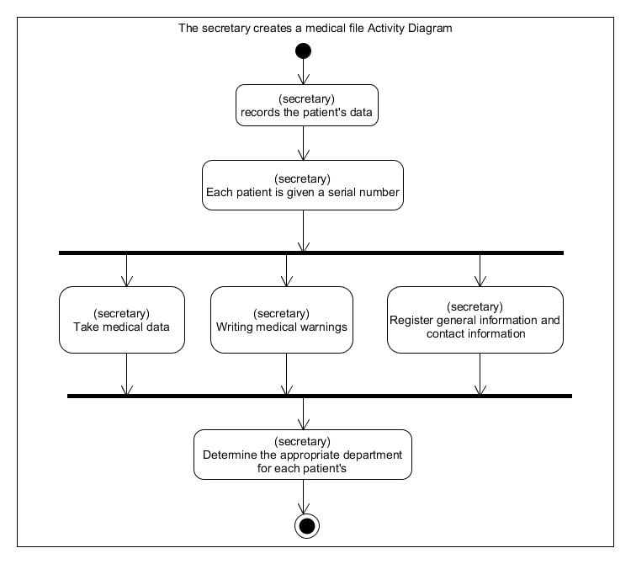

**System requirements.**

* **System Actor:**

1. **Patient:** The person who uses the clinic’s website to book an appointment to visit the clinic and take the appropriate treatment.
2. **Member:** The patient who has a login page with a username and password to get appointments for upcoming sessions and view the medical file.
3. **Secretary:** is the person who has a special login page with a user name and password so that patients’ appointments are recorded, a medical file for patients is created and the fees paid in the financial record of each patient are filled.
4. **Clinic manager:** is the person who has a login page with a username and password that contains all financial, administrative and medical records and the ability to follow and supervise them.
5. **Doctors:** A doctor has a login page with a user name and password that contains his work hours, patient reservations, medical files for each patient, and the ability to record what has been accomplished in each patient’s file.

* **System use case:**

**U1 : Reservation :** The patient books an appointment to go to the clinic through the website.

**U2 : proof of validity :** The secretary logs in with the validity code

**U3 : Create a medical file :** The secretary receives the patient in the clinic and creates a medical file that contains the patient’s information.

**U4 : Search:** The secretary searches for medical files on the patients' medical records page and booking appointments to confirm them.

**U5 : Login :** The member logs in using his username and password.

**U6 : Payment methods :** The member can pay in several different ways..

**U7 : Data review :** The member can view his data and financial record.

**U8 : View details :** The member can view the details and times of the reservation that have not expired yet.

**U9 : Cancellation of reservation :** The member can cancel the reservation through his own page and take another appointment for the reservation.

**U10 : Logout :** The user logs out of the site

**U11 : proof of validity :** The manager logs in with the validity code

**U12 : Reviewing all clinic files :** The clinic manager can view the files and review the financial files through his own page.

**U13 : proof of validity :** The doctor logs in with the validity code

**U14 : View the medical records of patients :** The doctor can view the medical records of each patient.

**U15 : Recording the data of each session :** The doctor writes down what was approved during the session.

* **Use case survey:**

The patient can book an appointment from the clinic’s website (U1), the secretary must prove the validity (U2) so that the secretary in the clinic when the patient is present creates a medical file containing the patient’s information (U3), and the website, after validating the validity, allows the secretary to confirm reservations And access to the medical records of patients (U4), the doctor must prove the validity (U13) and the website gives the doctor, after verifying the validity, the powers to access the medical records of patients (U14), and the patient who needs several sessions becomes a member and gets a user name and password (U5), enabling him From viewing his data and financial record (U7), and displaying upcoming appointments (U8), and the site allows him to cancel reservations or view other appointments (U9), and log out of the site (U10), the doctor can, after establishing the validity, register the patient’s data after each Session (U15), upon completion of the sessions, the website allows the member to pay in several ways (U6), the manager must prove validity (U11) to give him the authority to view the medical records in the clinic (U12).

* 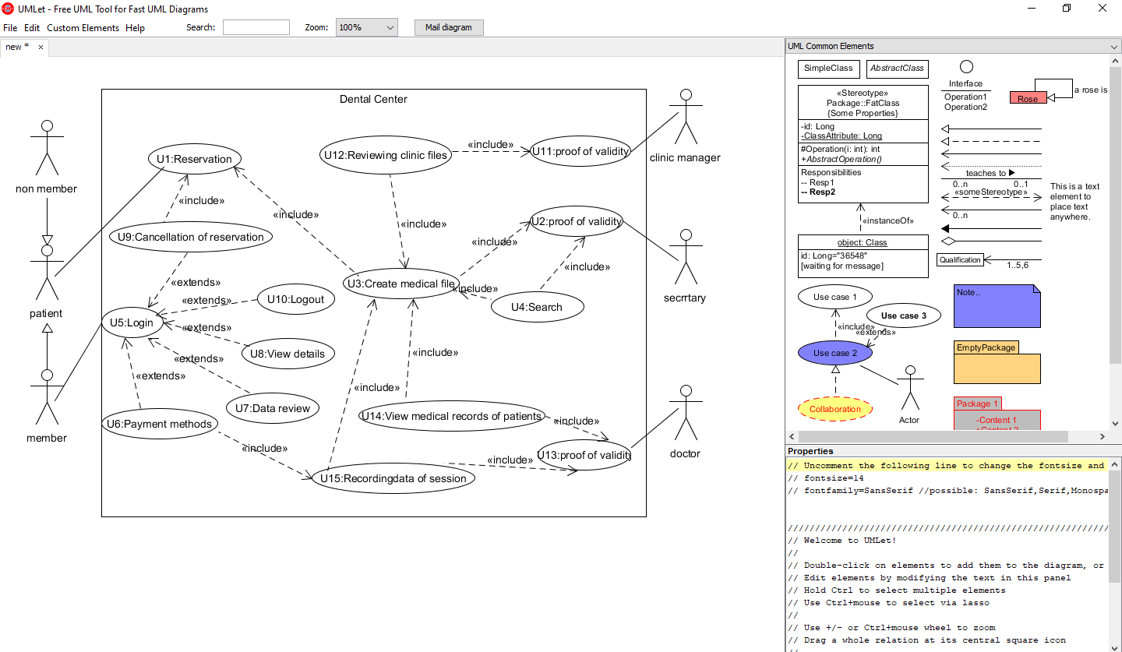**Use case diagram**
* **System use case details:**

**U1: Reservation (include by U9 and U3)**

Precondition: none

1. The patient opens the site
2. Go to the booking page
3. Fill in the required information

Postcondition: Confirm the reservation via the Confirm button

**U2: Proof of validity (include by U3 and U4)**

Precondition: Possession of a valid validity code

1. The secretary writes his authorization code
2. Press the confirm button

Postcondition: The page that contains the things he does will open for him

Abnormal paths

a1. The validity code is incorrect

**U3: Create a medical file (include by U4,U12,U14 and U15, include U1)**

Precondition: the presence of the patient in the clinic

1. The patient gives his information to the secretary
2. The secretary creates a medical file containing the patient’s data
3. The secretary directs the patient to the doctor

Postcondition: none

**U4: search (include U3)**

Precondition: Presence of medical files

1. The secretary goes to the medical page for patients
2. The secretary enters the serial number of the file
3. The patient's medical file appears

Postcondition: none

**U5: Login (extend by U10,U6,U7,U8 and U9)**

Precondition: The user must have a valid username and password

1. Enter your username
2. Enter the password
3. Click on the login button

Postcondition: The user is now logged in to the site

**U6: payment methods (include U15, extend U5)**

Precondition: The member has at least one payment method

1. extend U4
2. Open the payment page
3. The patient chooses the appropriate payment method for him
4. He pays the required amount

Postcondition: Press the Confirm button

**U7: data revision (extend U5)**

Precondition: none

1. extend U4
2. Open the patient data page
3. Show his medical file

Postcondition: none

**U8: View details (extend U5)**

Precondition: none

1. extend U4
2. Open the patient details page
3. Show booking dates

Postcondition: none

**U9: cancel reservation (include U1, extend U5)**

Precondition: none

1. extend U4
2. Opening the patient's reservations page
3. The possibility of canceling the reservation and making another appointment

Postcondition: Click on the Confirm Booking Appointment button

**U10: logout (extend U5)**

Precondition: none

1. extend U4
2. Press the logout button

Post condition: The user is logged out of the site

**U11: Proof of Validity (include by U12)**

Precondition: Possession of a valid validity code

1. The manager writes his authorization code
2. Press the confirm button

Post condition: The page that contains the things he does will open for him

Abnormal paths

a1. The validity code is incorrect

**U12: View all medical files (include U3)**

Precondition: none

1. include U3
2. Open the database that contains all medical and financial records

Postcondition: none

**U13: Proof of validity (include by U14 and U15)**

Precondition: Possession of a valid validity code

1. The doctor writes his validity code
2. Press the confirm button

Postcondition: The page that contains the things he does will open for him

Abnormal paths

a1. The validity code is incorrect

**U14: Review of a patient's medical records (include U3)**

Precondition: Possession of authority

1. include U3
2. Open the patient's medical records page

Postcondition: none

**U15: Recording session data (v U3, include by U6)**

Precondition: none

1. include U3
2. Opening the patient's medical file
3. Recording session data

Postcondition: Press the Save button

* **Supplementary Requirements:**

**S1:** The system can handle 500 users at the same time.

**S2:** The system was created by language HTML,CSS,JS.

**S3:** The system saves a maximum of 6000 files.

* **User interface sketches:**

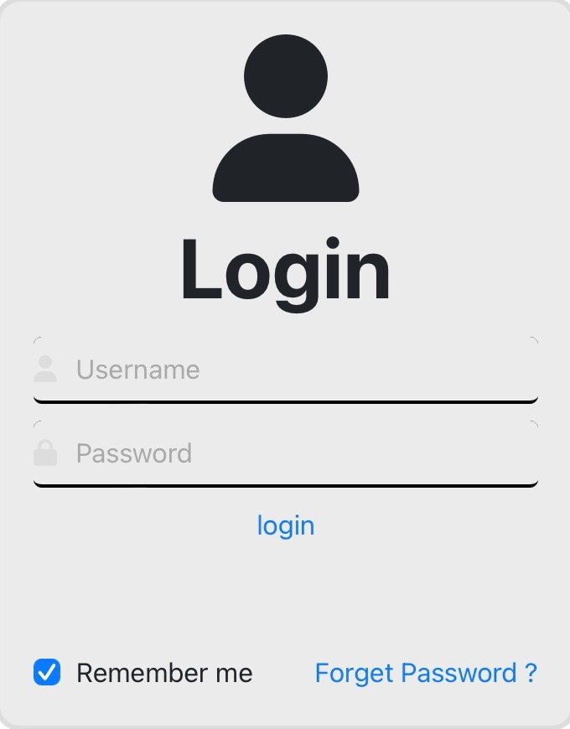1:

2

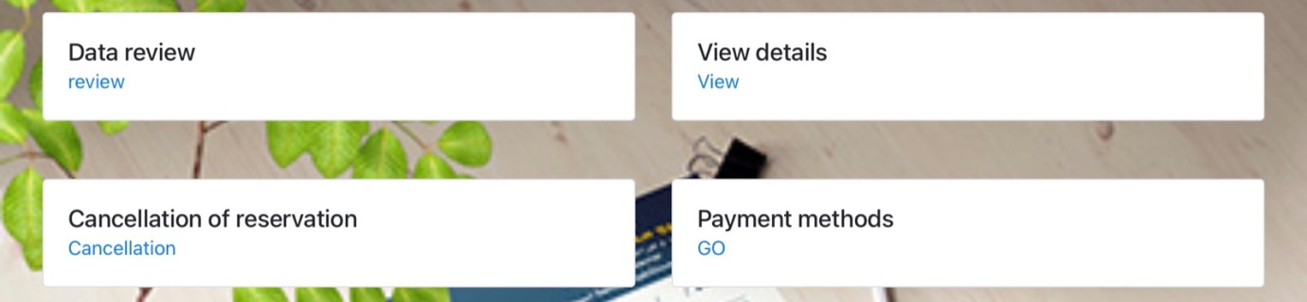2:

4

3

5

66

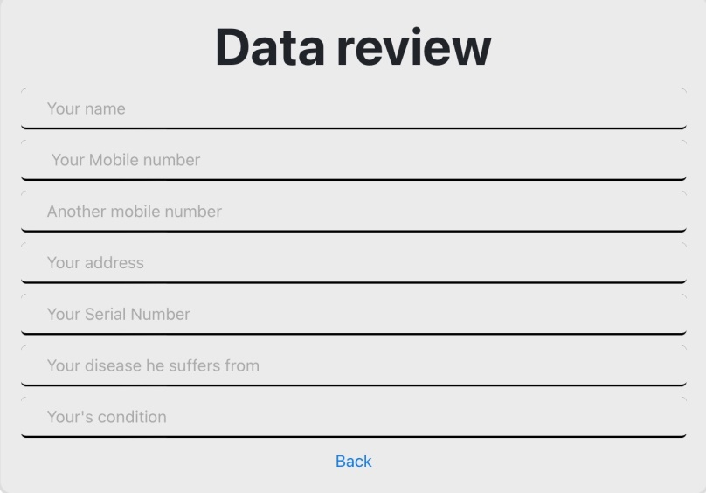3:

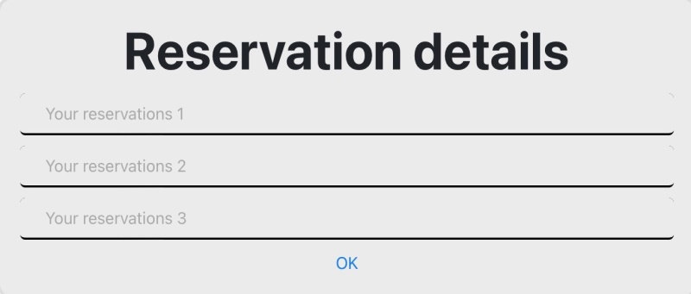4:

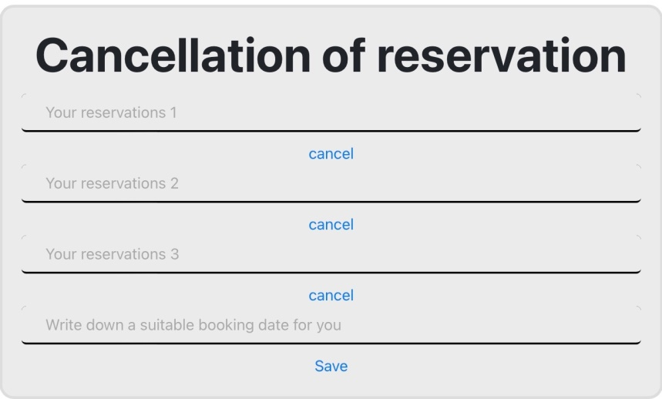5:

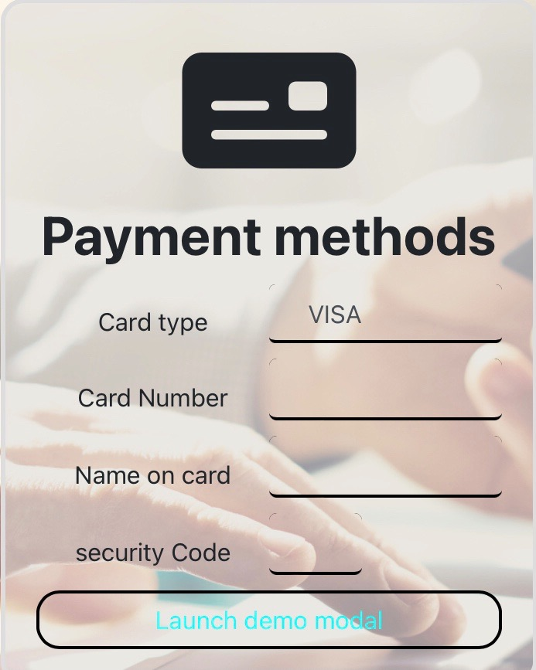6:

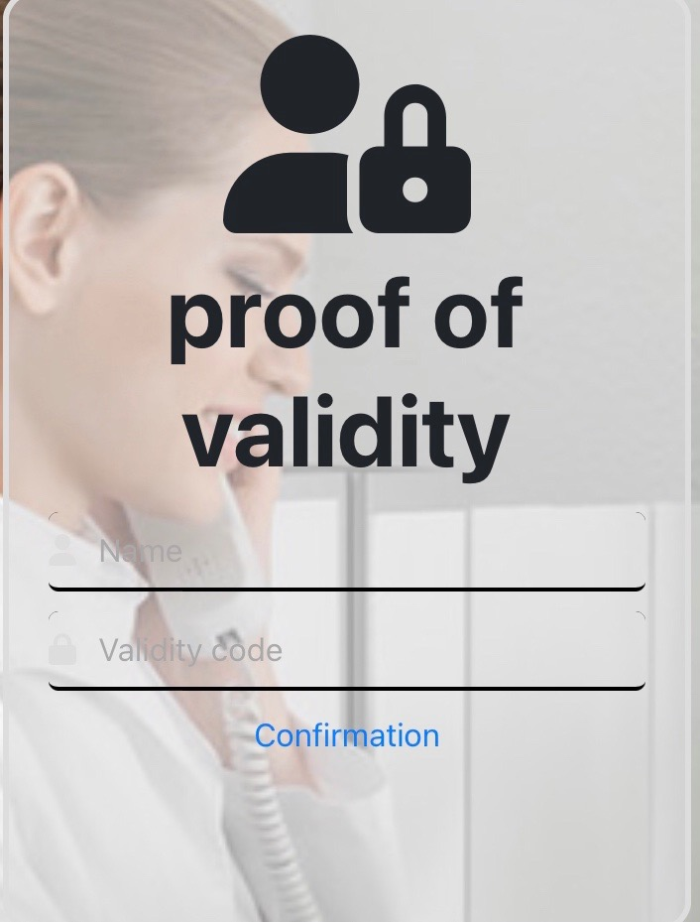7:

8

8:

10

9

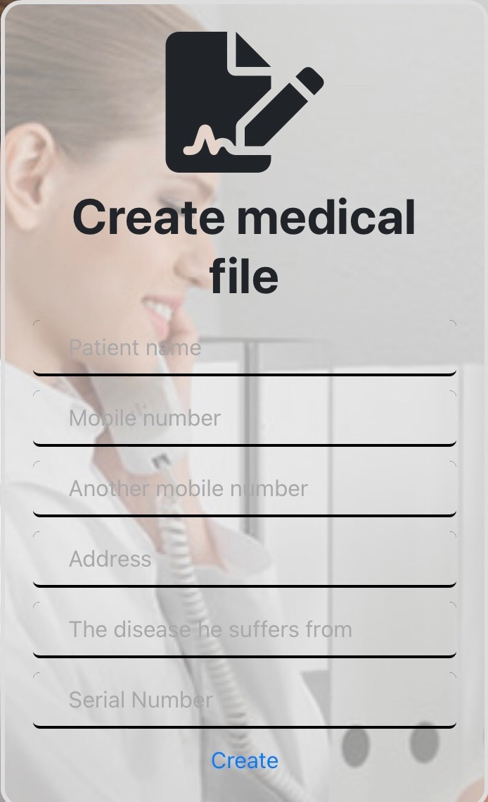

9:

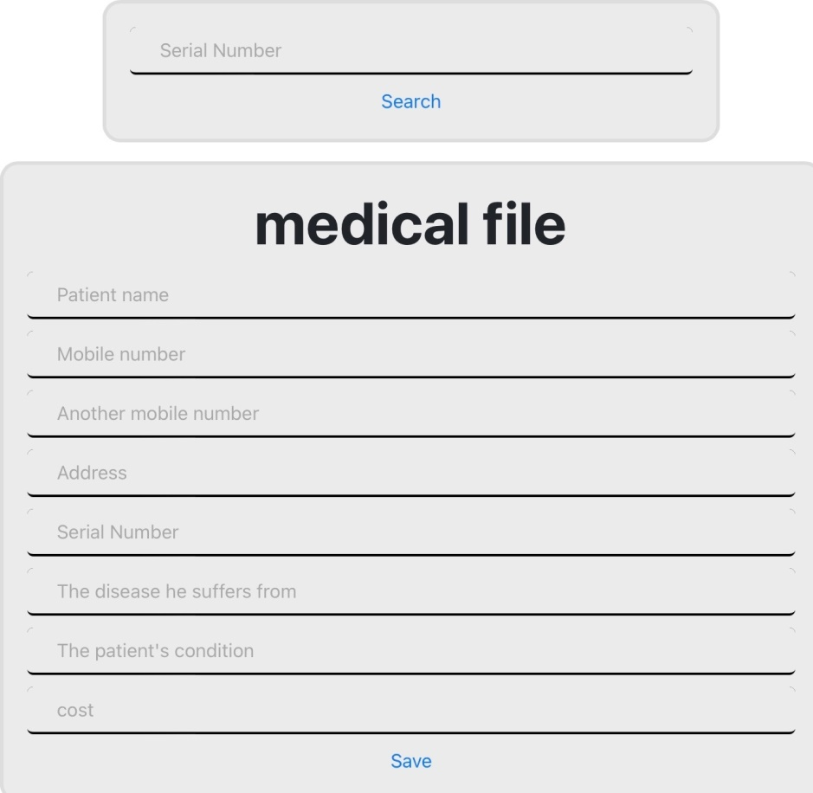10:

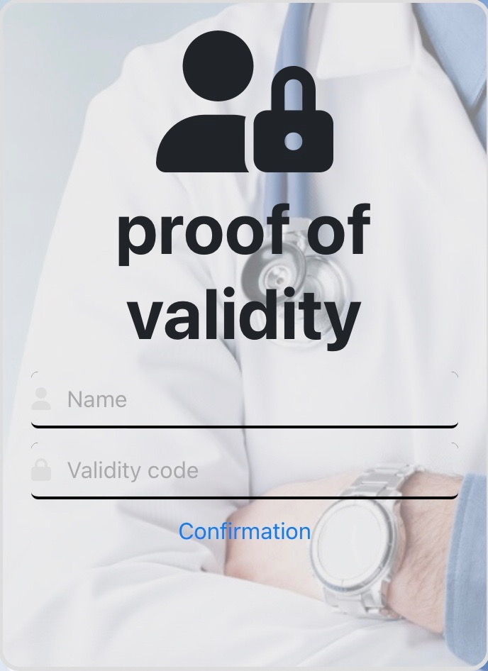11:

12

12:



14

13

13:

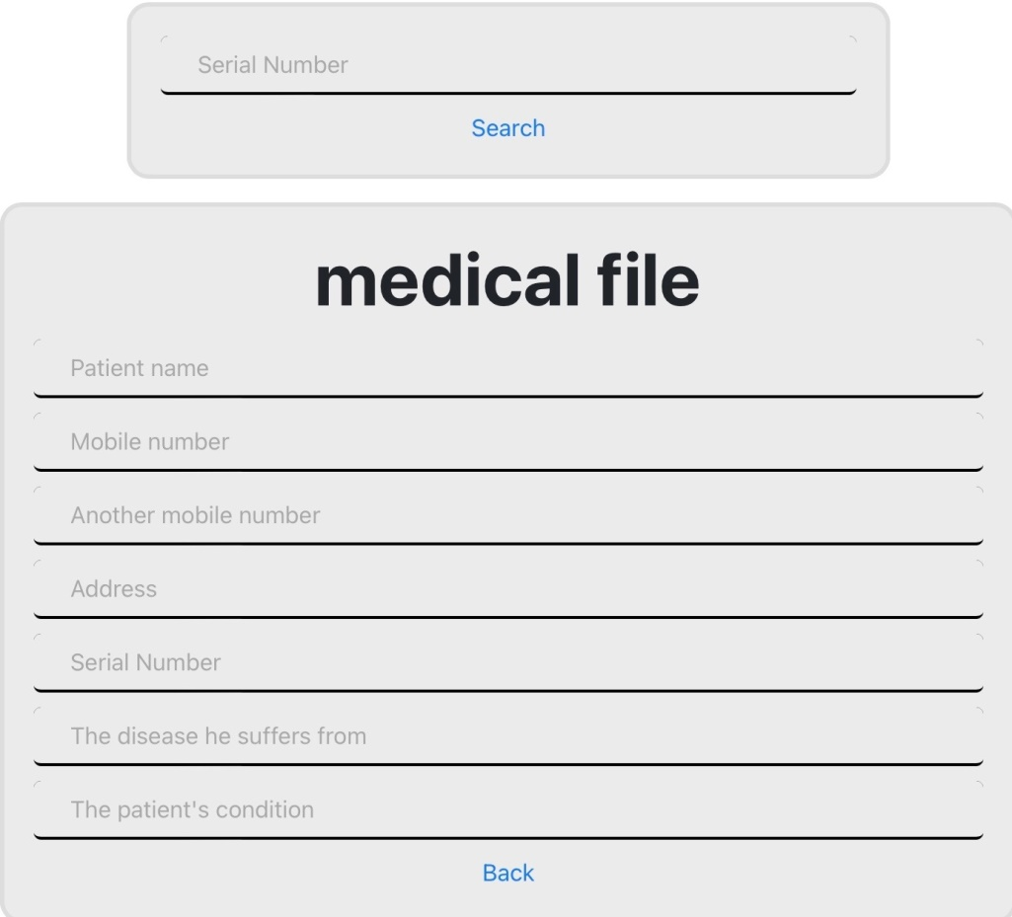

14:

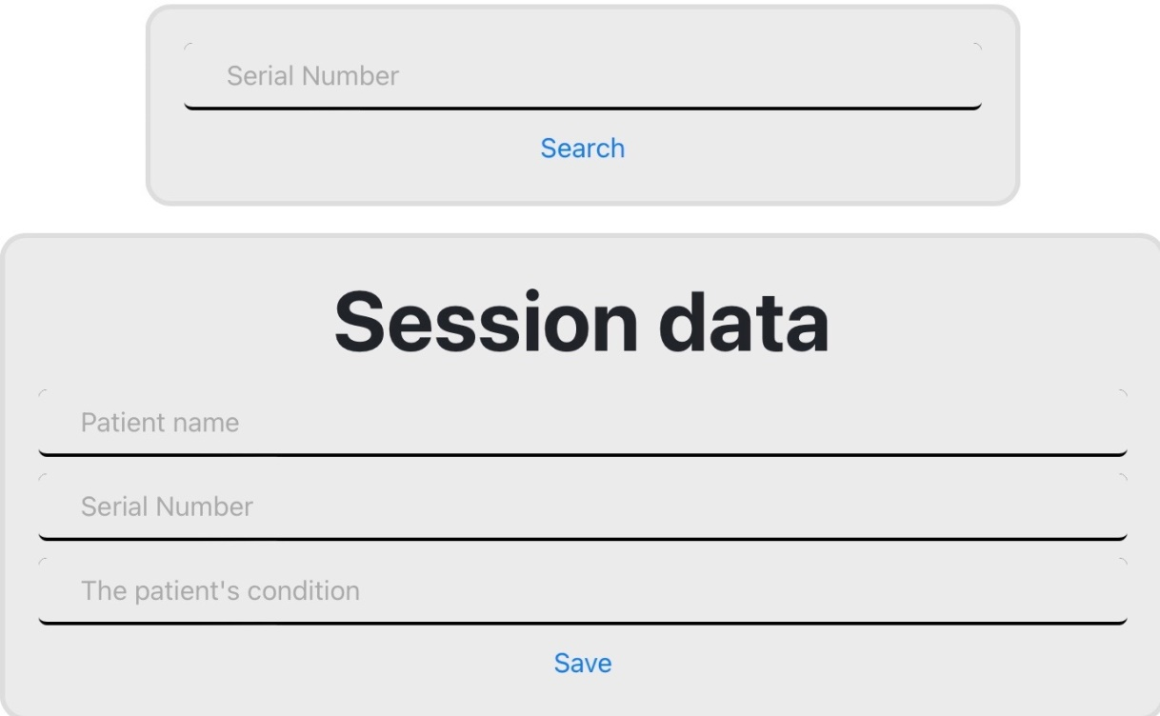

15:

16

16:

17

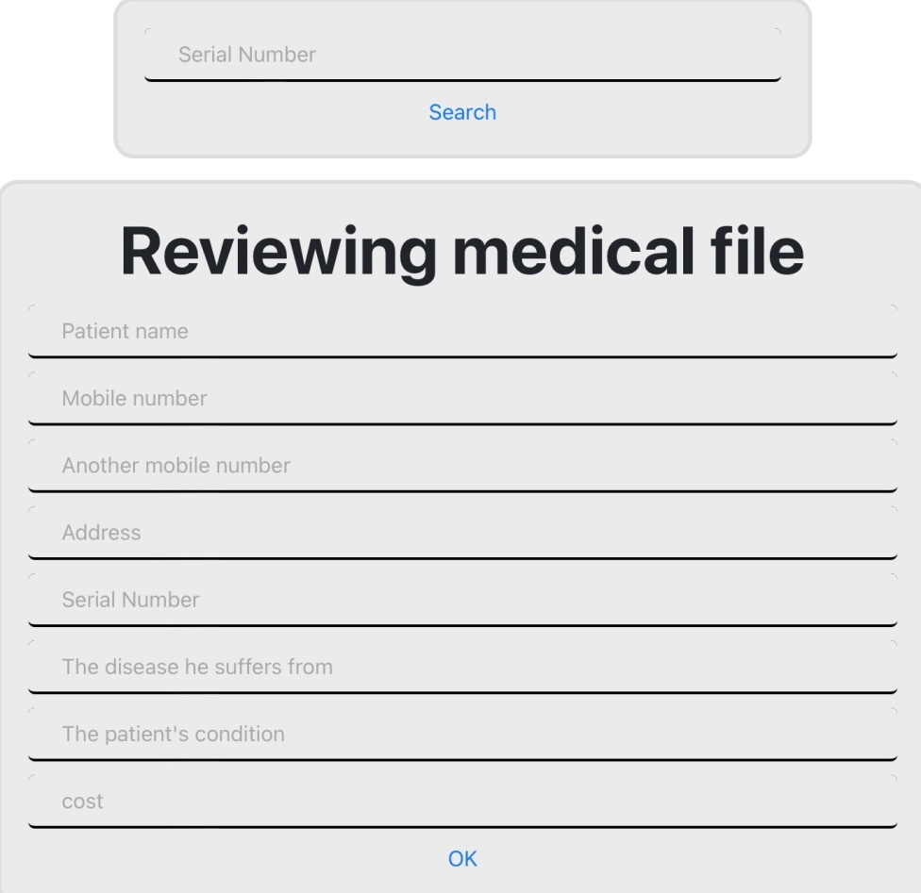17:

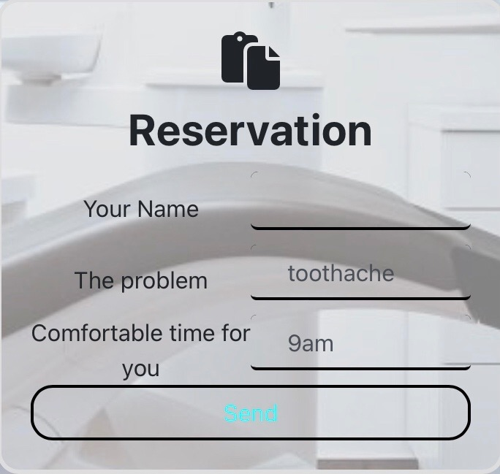18:

* **Prioritizing system use case:**

**Green:**

* U1 : Reservation
* U5 : Login
* U2:proof of validity
* U11:proof of validity
* U13:proof of validity

**Amber**:

* U3 : Create a medical file
* U4 : Search
* U10 : Logout
* U9 : Cancellation of reservation
* U8 : View details
* U7 : Data review

**Red**:

* U14 : View the medical records of patients
* U15 : Recording the data of each session
* U5 : Payment methods
* U10 : Reviewing all clinic files

**Analyzing**

* **Class diagrams :**

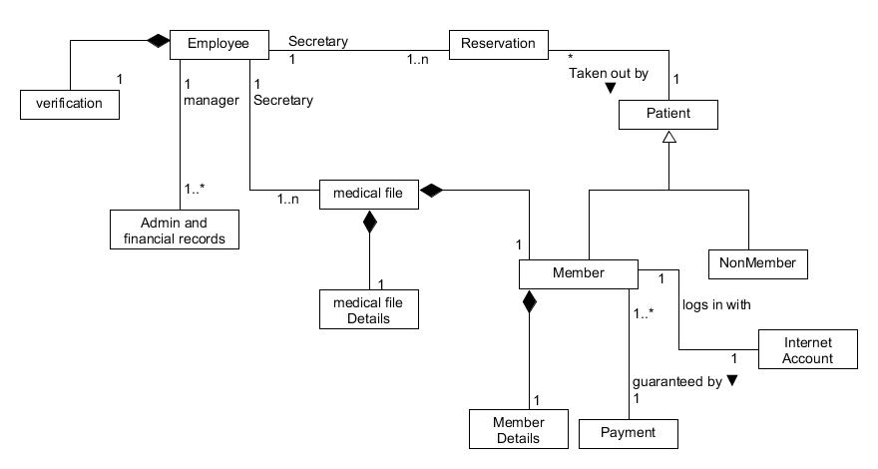

* **Communication diagram for all use case:**
* **U1 : Reservation**

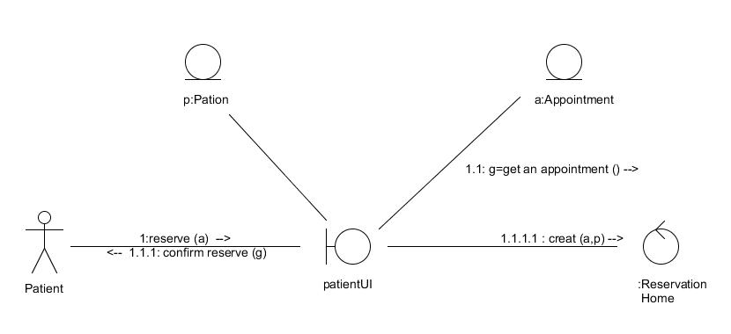

* **U2 : proof of validity**

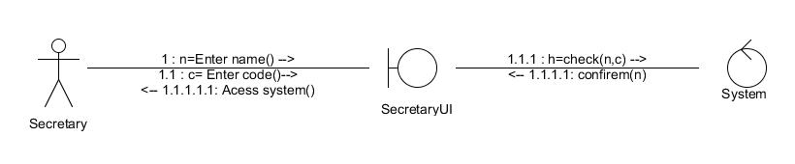

* **U3 : Create a medical file**

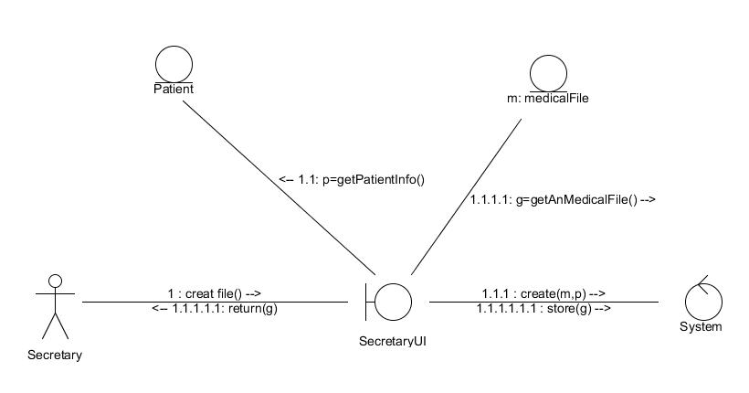

* **U4 : 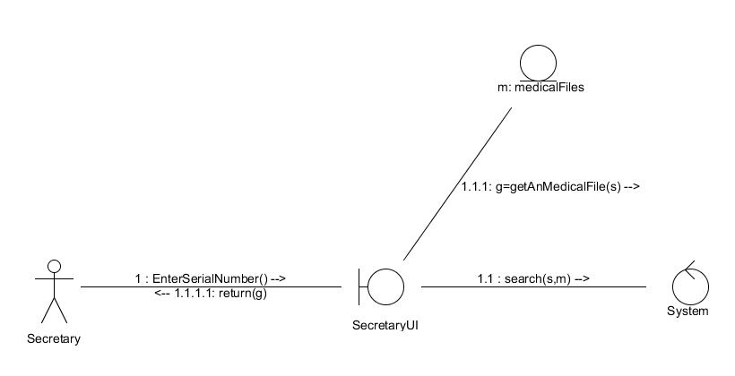Search**
* **U5 : Login**

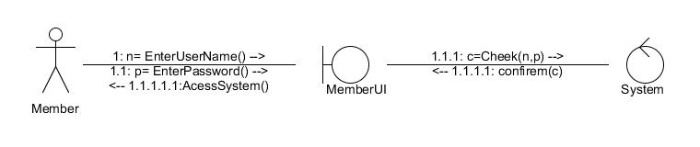

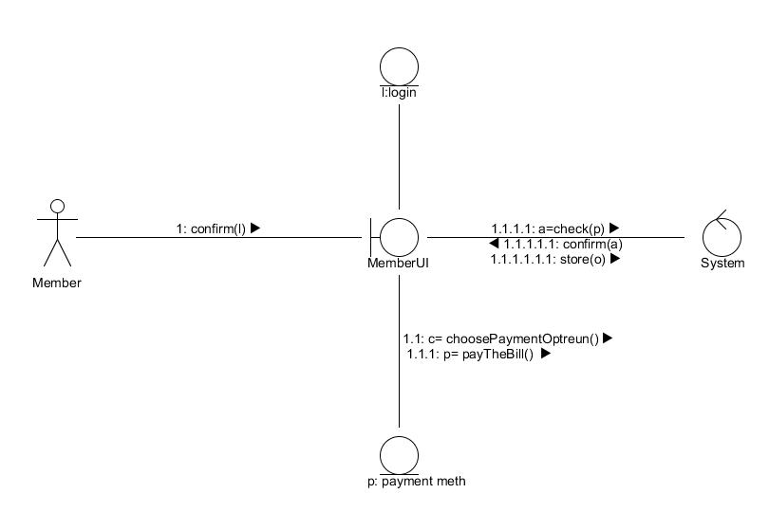

* **U6 : Payment methods**

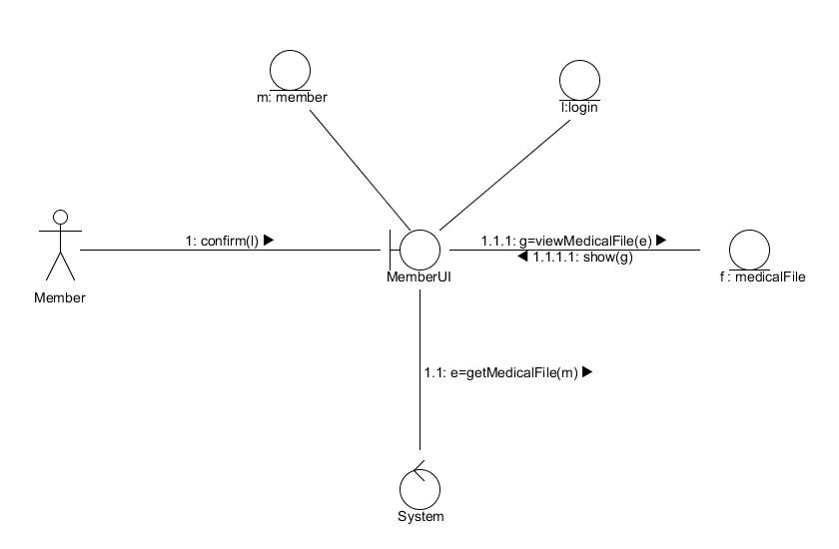

* **U7 : Data review**
* **U8 : 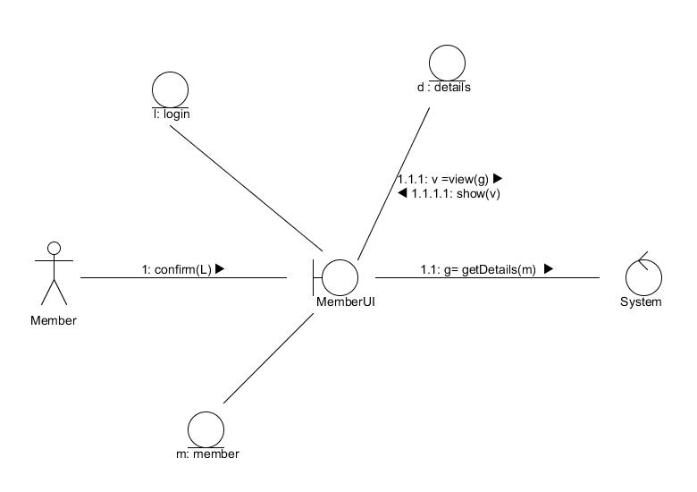View details**
* **U9 : Cancellation of reservation**

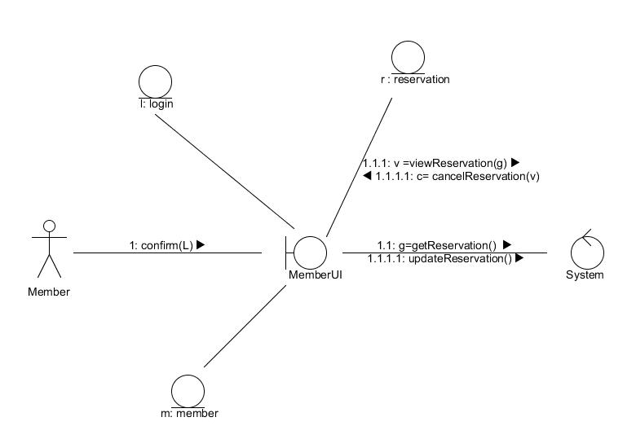

* **U10 : Logout**

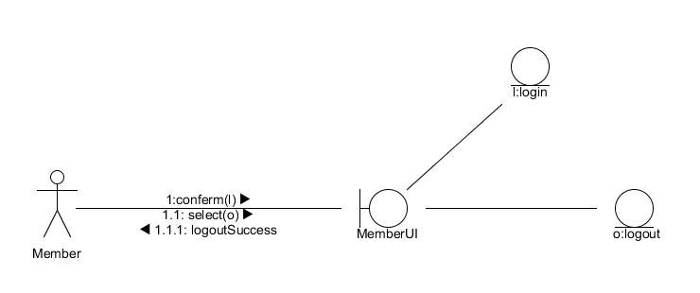

* **U11 : proof of validity**

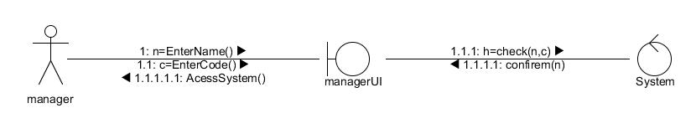

* **U12 : Reviewing all clinic files**

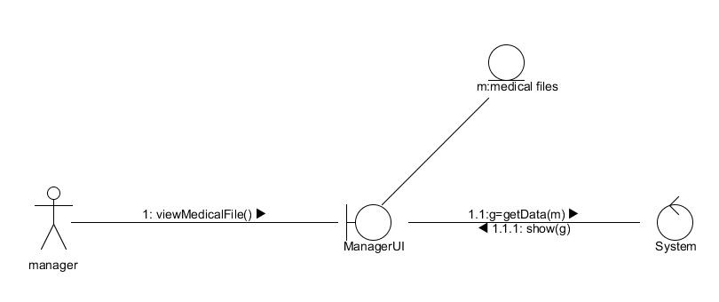

* **U13 : proof of validity**

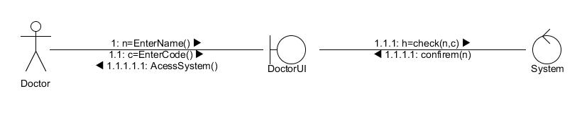

* **U14 : View the medical records of patients**

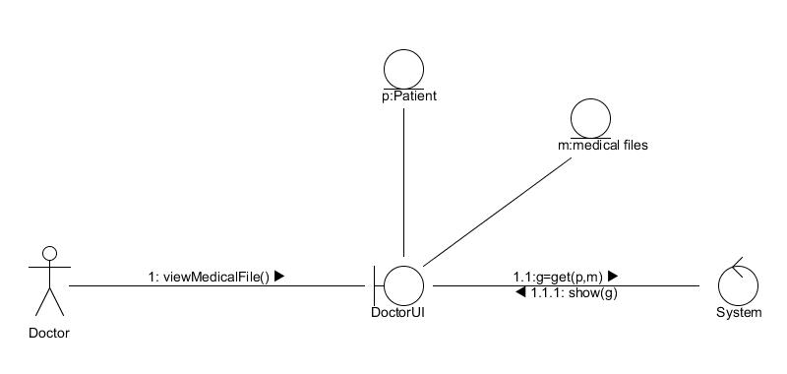

* **U15 : Recording the data of each session**

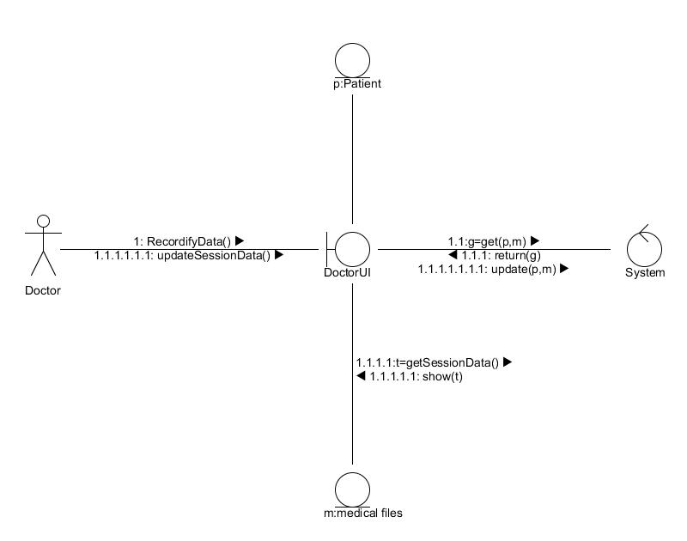

* **State machine diagram for a reservation :**

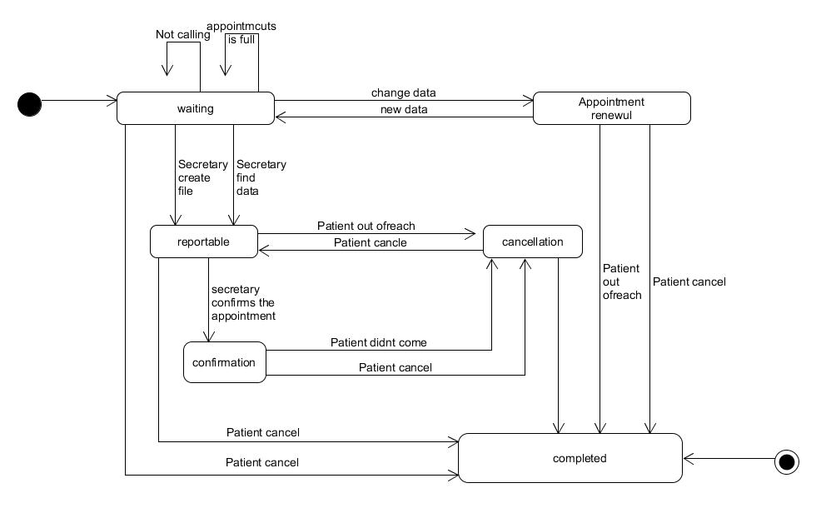

**Design**

* **Class diagrams details :**

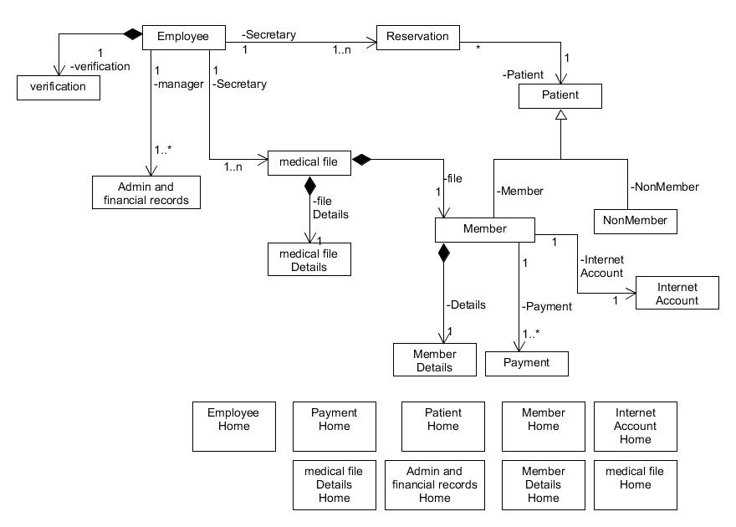

* **Persistence with a relational Database :**
* PATIENT ( ID:INTEGER,NAME:STRING,ADDRESS:VARCHAR(99),AGE:INTEGER,GENDER:STRING, PHONENUMBER:INTEGER,WALK IN DATE:DATE,NEXT SCHEDULE:DATE)
* EMPLOYEE ( ID:INTEGER,NAME:STRING,PHONENUMBER:INTEGER,EMAIL:STRING)
* VERIFICATION (ID:INTEGER,EMPLOYEENAME:STRING,VALIDITYCODE:INTEGER)
* MEMBER (ID:INTEGER,USERNAME:STRING,PASSWORD:INTEGER)
* NONMEMBER (ID:INTEGER,NAME:STRING,PHONENUMBER:INTEGER)
* MEMBERDETAILS(ID:INTEGER,NAME:STRING,PHONENUMBER:INTEGER,ANOTHERPHONENUMBER:INTEGER,ADDRESS: VARCHAR(99),SERIALNUMBER:INTEGER,MEMBERDISEASEHESUFFERSFROM:STRING, MEMBERCONDITION:STRING)
* APPOINTEMENT(ID:INTEGER,PATIENTID:INTEGER,PATIENTNAME:STRING,APPOINTEMENTDATE:DATE, APPOINTMENTTIME:TIME)
* INTERNET ACCOUNT (ID:INTEGER,PASSWORD:VARCHAR(99), SESSIONID:INTEGER)
* PAYMENT (ID:INTEGER,CARDTYPE:INTEGER,CARDNUMBER:INTEGER,NAMEONCARD:STRING,

SECURITYCODE:INTEGER)

* RESERVATION(ID:INTEGER,PATIENTNAME:STRING,THEPROPLEM:STRING,COMFORTABLETIMEFOR PATIENT:TIME)
* MEDICALFILE (ID:INTEGER, PATIENTNAME:STRING,ADDRESS:VARCHAR(99), PHONENUMBER:INTEGER, SERIALNUMBER:INTEGER,THEDISEASEHESUFFERSFROM:STRING)
* MEDICALFILE DETAILS (ID:INTEGER,PATIENTNAME:STRING,ADDRESS:VARCHAR(99),PHONENUMBER:INTEGER,ANOTHERMOBILENUMBER:INTEGER,SERIALNUMBER:INTEGER,THEDISEASEHESUFFERSFROM:STRING,PATIENTCONDITION:STRING,COST:INTEGER)
* ADMINANDFINCIALRECOREDS(ID:INTEGER,PATIENTMUSTPAID:INTEGER,PATIENTPAID:INTEGER,TOTALAMOUNT:INTEGER,CLINICPROFITABLE:INTEGER,NOTES: VARCHAR(99))
* **User Interfaces :**

1. **Login page for secretary**

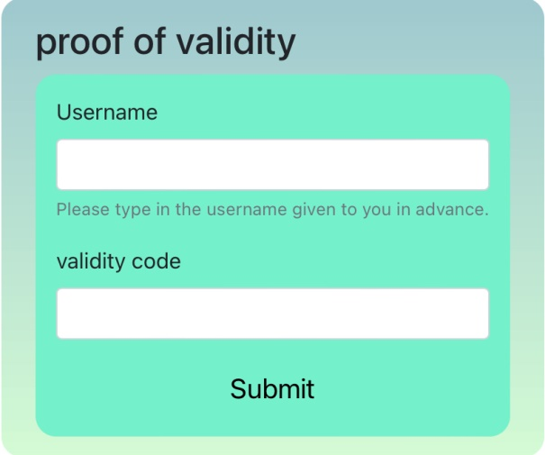

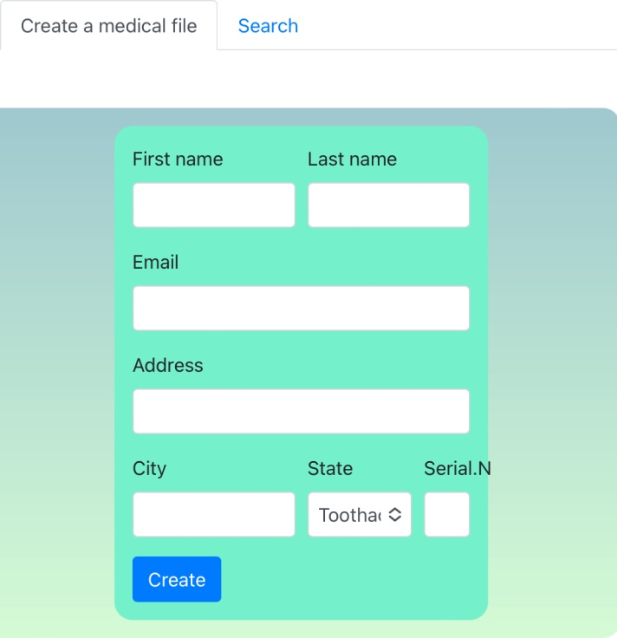

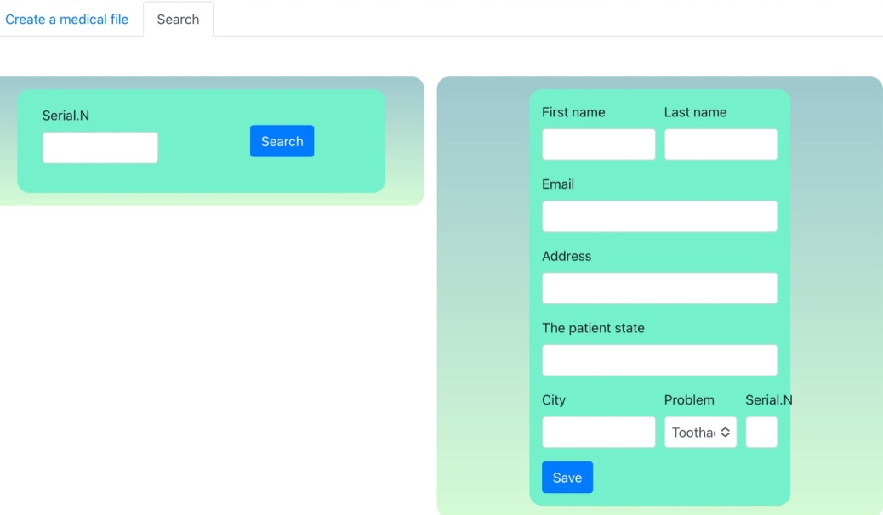

1. **Login page for Doctor**



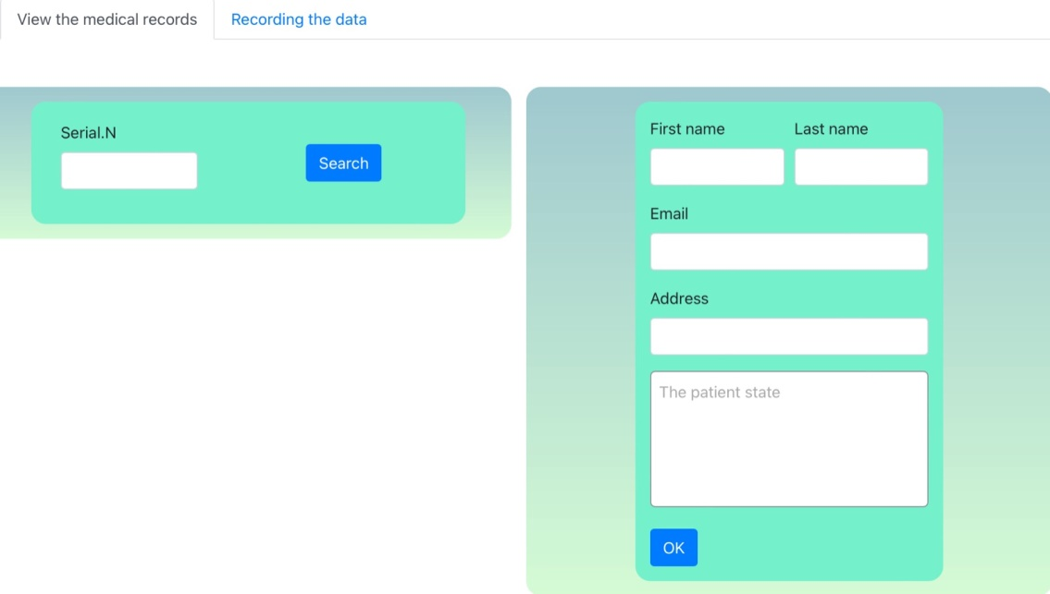

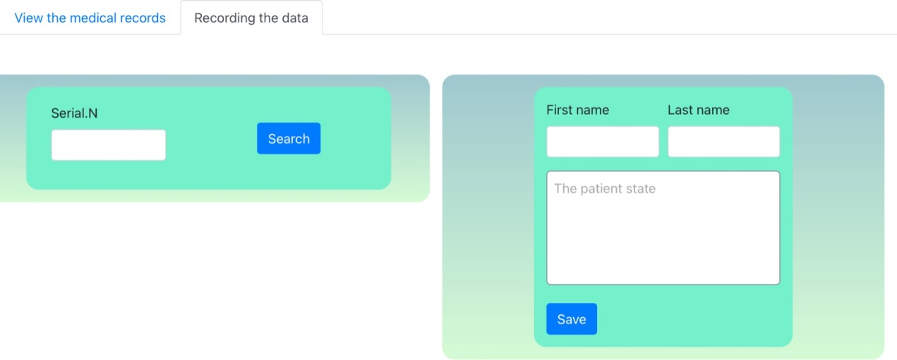

1. **Login page for manager**



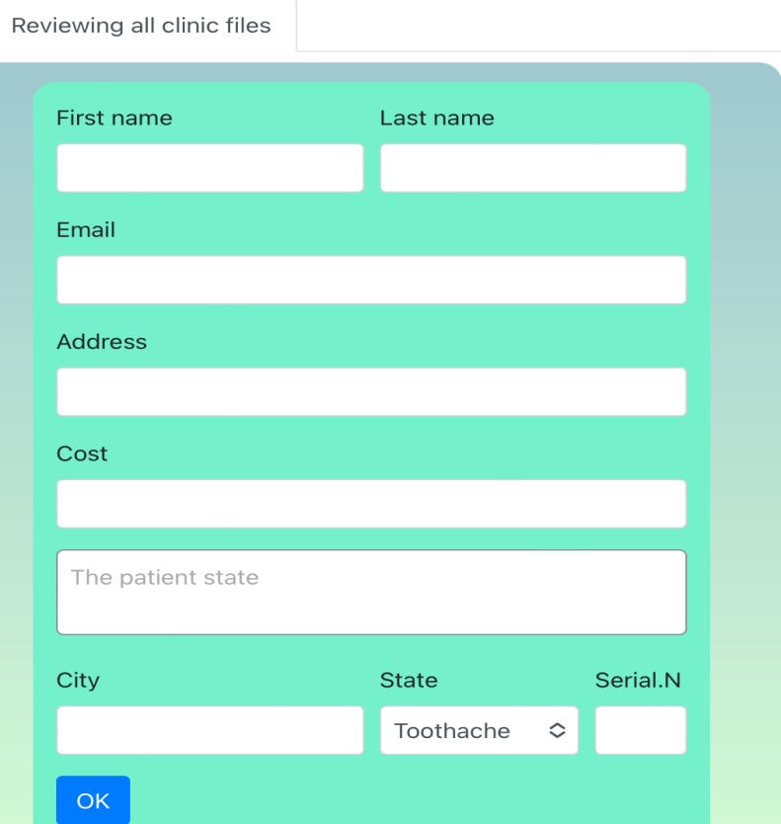

1. **Login page for member**

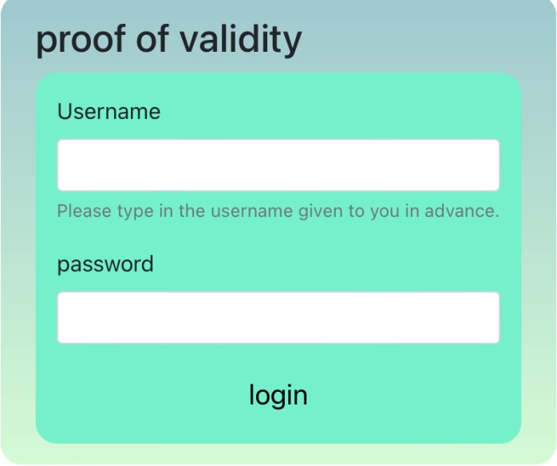

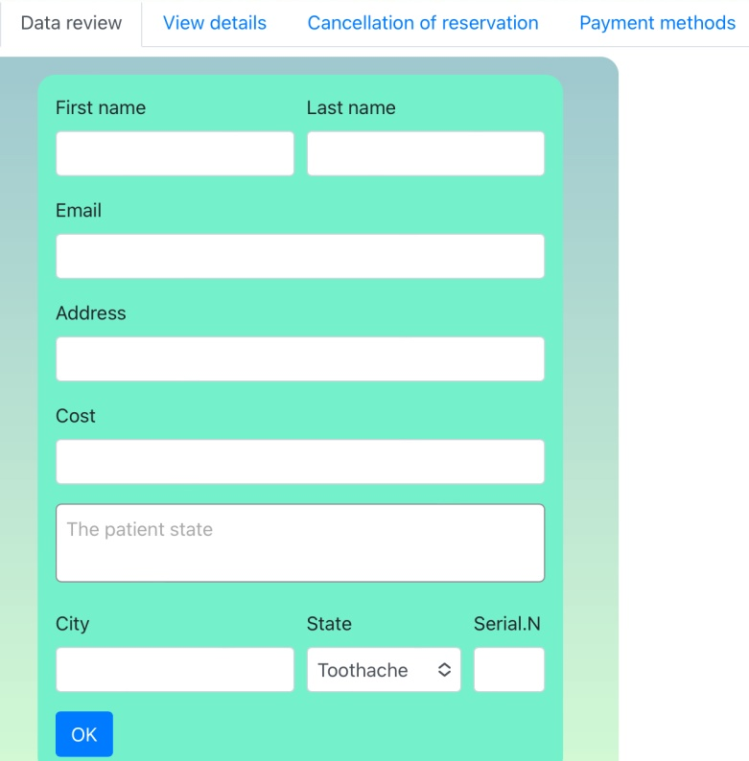

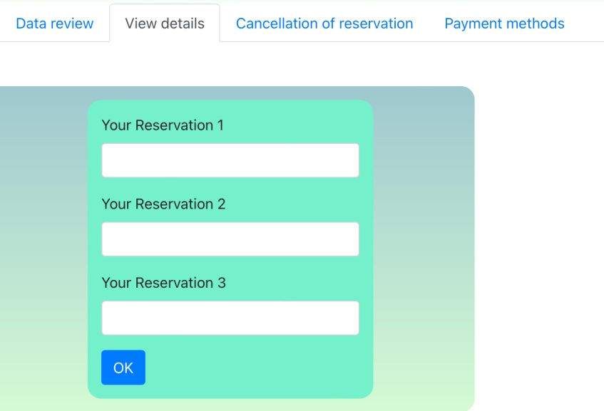

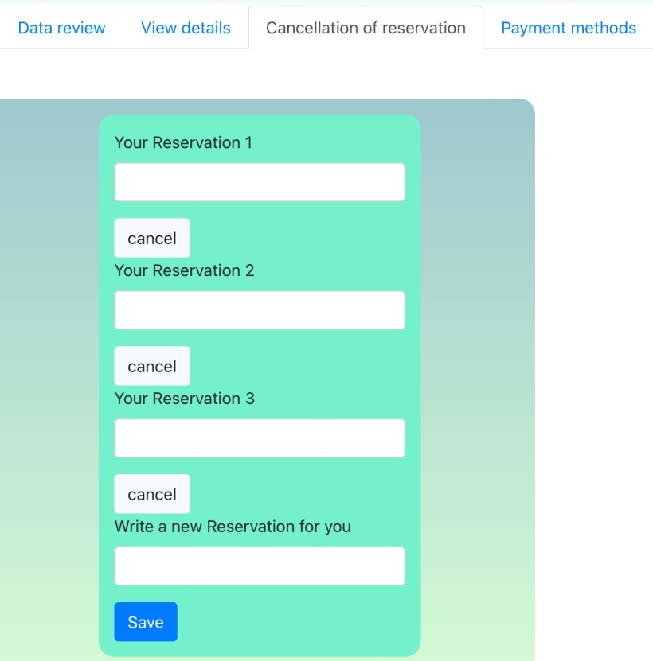

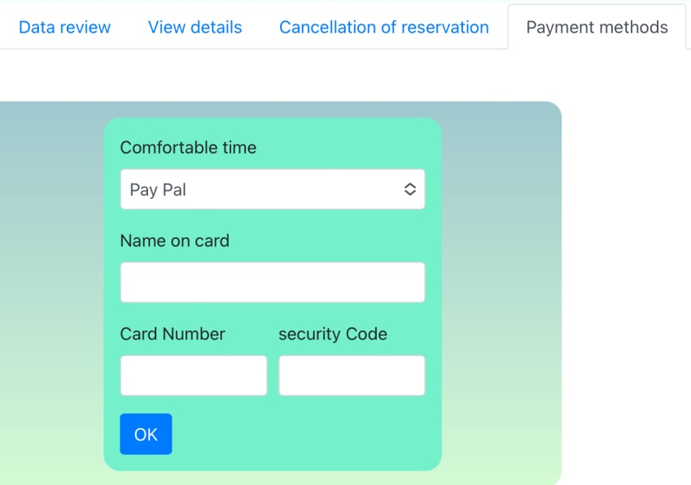

1. 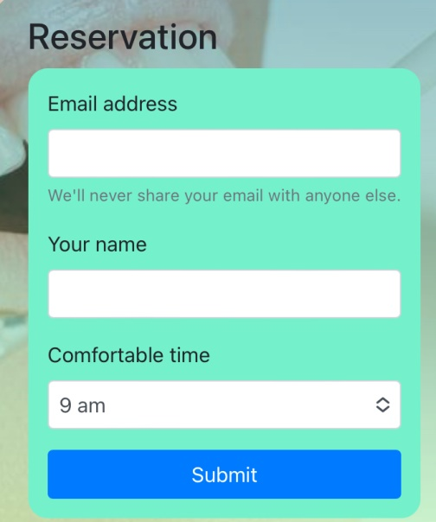**Reservation**

* **Sequence diagram :**
* **Reservation use case:**

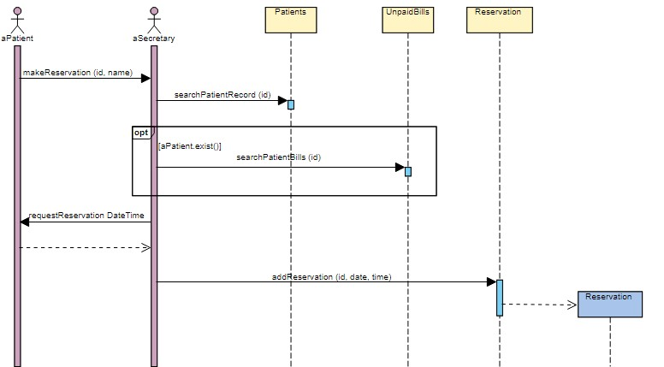

* **login use case:**

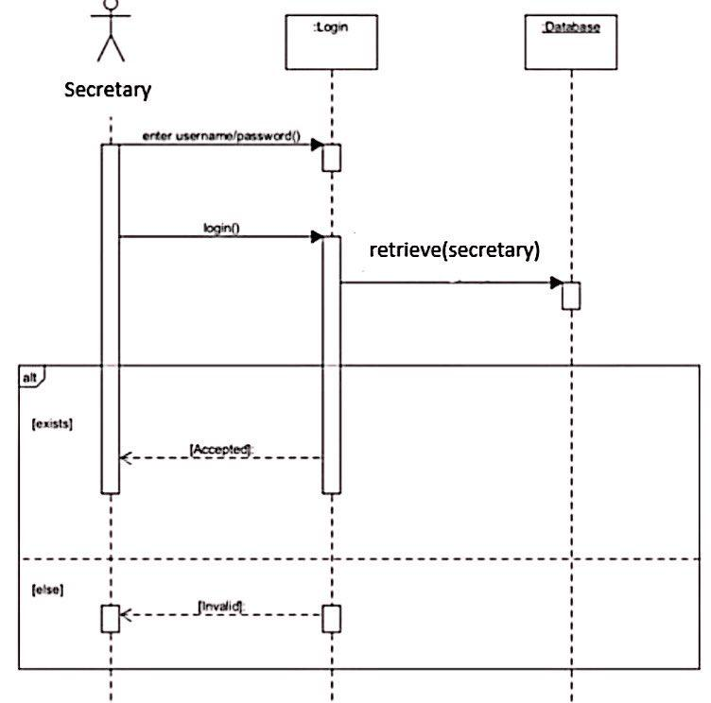

* 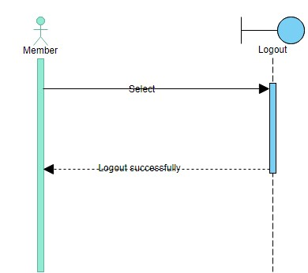**logout use case:**
* **Cancel reservation use case:**

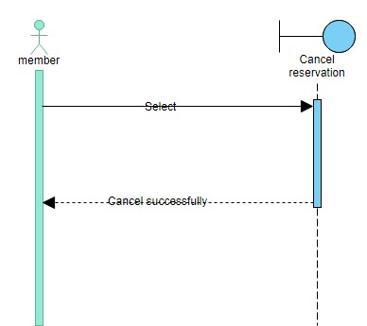

* **Payment method use case :**

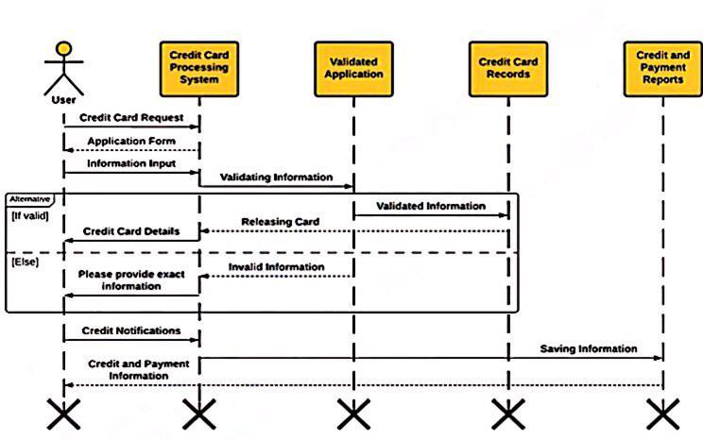

* **proof of validity use case : (secretary)**

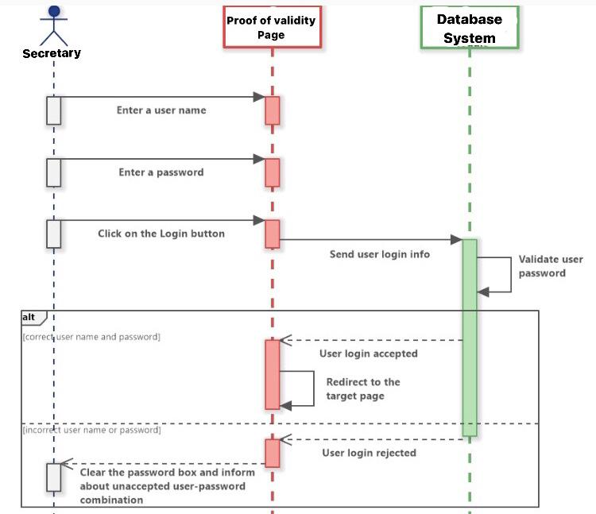

* 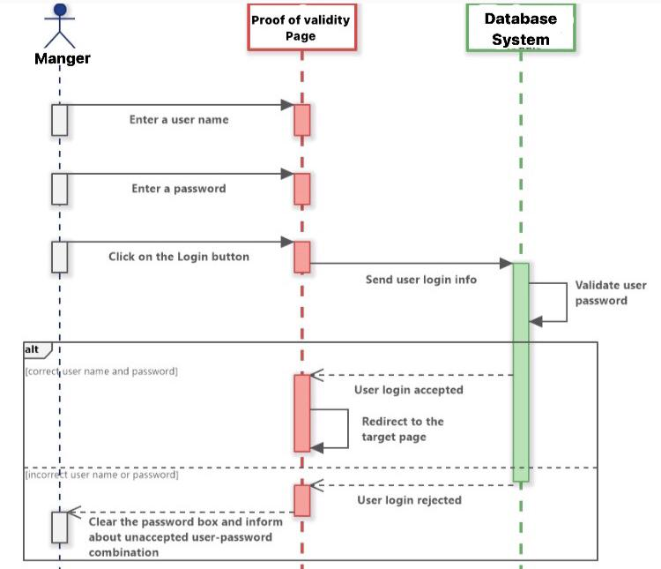**proof of validity use case : (Manger)**
* **proof of validity use case : (doctor)**

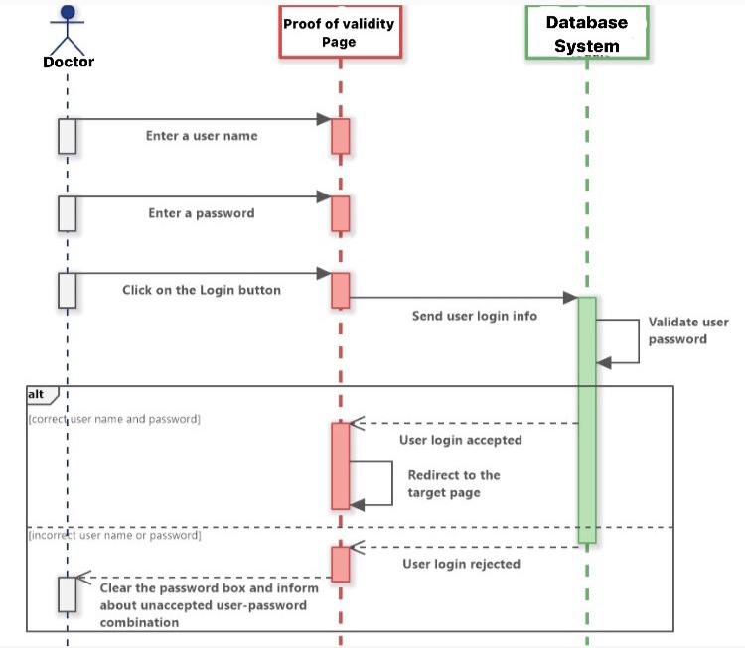

* **Recording session data use case :**

